1. 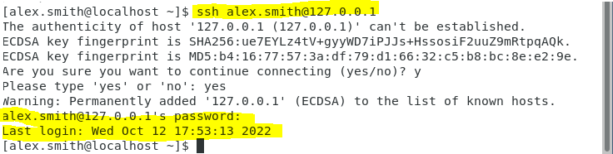Screenshot of SSH command to log in as alex.smith.
2. Screenshot of the SSH command to log in as alex.smith using the key file over the non-standard port of 44022 .

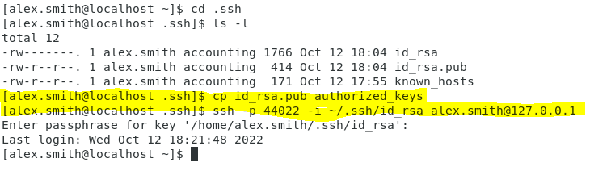

1. 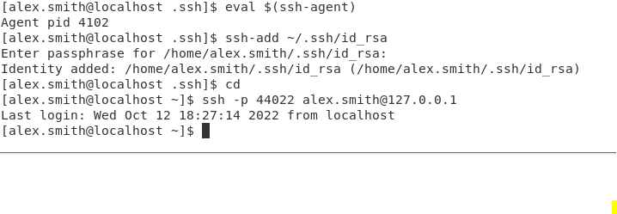Screenshot of enabling the ssh-agent, loading the private key into the ssh-agent using the ‘ssh-add’ command, and then successfully ssh’ing without needing to input the identity file or enter the passphrase.